ECE x60: Emb. Sys. ARchitectures
Final Project: Shields UP! Report Template v1.0
Name, Partner name
Email address, Partner email address
NOTE: Your responses for questions 2 and 3 must be entered in the CSV spreadsheet.

Introduction
Brief introduction to your report.

Synchronization

Mutual Exclusion for LCD Update Operations

Timing Analysis for Base Code
- Provide two screenshots of the logic analyzer with trace and measurement windows showing each thread accessing the mutex (i.e. there must be a pulse on the LCD blocking signal).

Synchronization for Scope Waveform Display
- In your report, explain briefly your approach(es) and reasons for your choice(s).

Fault Analysis and Management
- EVIDENCE: Provide scope/logic analyzer screenshots and diagrams (as needed) to support your case. Include any debug signals needed to show that the system is working as you explain in your text.
- PAGE LIMIT: Use no more than one page in the report per fault test. Use a 9-point font for your text. Choose your images and words carefully to convey the information concisely.

Fault Test n (One for Each Fault Addressed)

Fault Analysis
- Explain how the fault (when not managed) affects the system.

Fault Management Approach
- Explain your fault management approach,
- Provide details of how you changed the system to manage the fault.

Evaluation of Effectiveness
- Evaluate the time taken to detect and manage the fault.
- Explain the impact (if any) of the managed fault on the system.
- If you restart the system, evaluate the time taken to restart it (from fault to normal operation).

Retrospective
- Lessons learned in this project, and how you might do things differently next time
  - Technical issues (processor, peripherals, compiler, tools, assembly code, etc.)
  - Changes to your own development process
- Optional: How would you change this project (and related course material) to make it more effective and feasible?

Example Fault Test

Fault Analysis

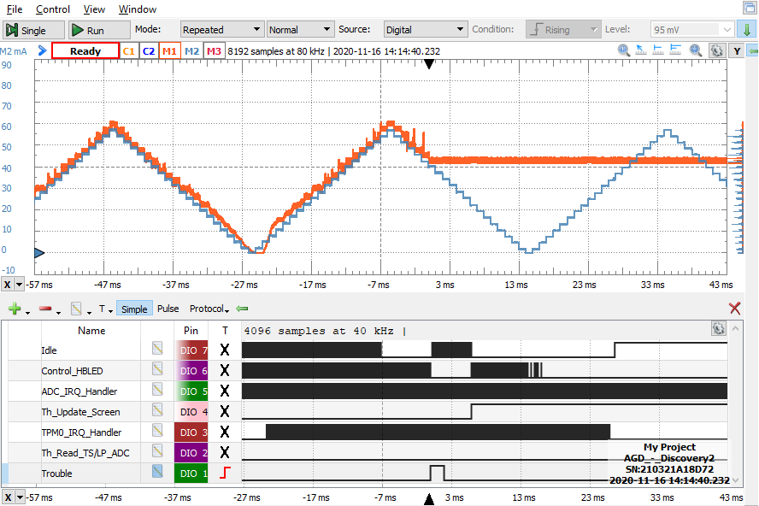  Figure 0.1. LED current does not follow setpoint after fault disables controller. | 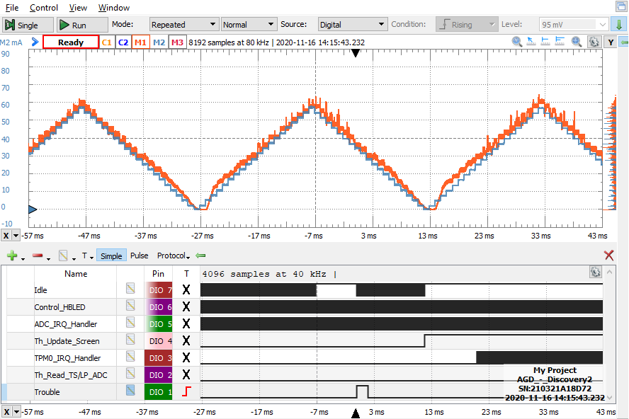  Figure 0.2. Fault detection and response code corrects variable and keeps controller enabled without much change in system behavior.
The fault overwrites the g_enable_control variable with the value 0 to disable control. Figure 0.1 shows that this causes the system to run open-loop, so the PWM duty cycle and LED brightness remain unchanged until user interaction or system reset.

Fault Management Approach
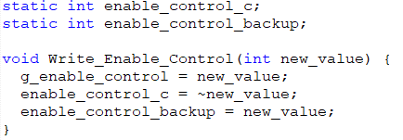
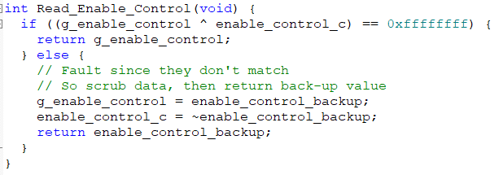
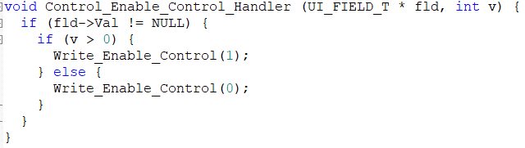
Figure 0.3. Key source code additions.
The fault in g_enable_control is detected using a complement variable g_enable_control_c. The response uses a backup variable enable_control_backup. These two variables are file-static to limit their visibility and protect them. Two “getter/setter” functions are added: Write_Enable_Control and Read_Enable_Control. All valid accesses to g_enable_control in the source code are modified to use these interface functions.
- To write to g_enable_control, use the function Write_Enable_Control. This updates g_enable_control and enable_control_backup with the parameter, and g_enable_control_c with the complement of the parameter. Write_Enable_Control is called by Init_Buck_LED for initialization and Control_Enable_Control_Handler (added to the project) to change the variable.
- To read from g_enable_control, use the function Read_Enable_Control. This first validates the variable by XORing it with g_enable_control_c. If the result is all ones (0xffffffff) then the value is valid and will be used. If not, the value is invalid so the system responds to the fault by returning the previously-saved variable enable_control_backup. Read_Enable_Control is called by Control_HBLED.
Note that the user interface (in UI.c and the callbacks such as Control_OnOff_Handler in control.c) was designed to access variables directly, rather than use getter/setter functions. A custom callback handler function Control_Enable_Control_Handler was used as shown. This is outside the scope of this project; you are not expected to modify the user interface and the callback functions.

Evaluation of Effectiveness
As shown in Figure 0.2, the system continues running normally without any noticeable problems with the output current. It takes a negligible amount of time to detect and manage the fault. Usually the fault is detected in Control_HBLED before g_enable_control is used again. Because Control_HBLED runs at 24 kHz, the fault will be detected within one period, which is 41.667 µs. There is a chance that the user interface code will modify the variable before this time and eliminate the fault. Most of the time overhead comes from calling Read_Enable_Control once each time Control_HBLED runs (24 kHz, or once every 2000 clock cycles). This is expected to be a minor performance penalty because Read_Enable_Control is such a short function.

